Movie Recommendation System Project (Report)

Leen Ghazi & Shahad Altheeb

***Introduction:***

The “Movie Recommendation System” is designed to provide information/recommendations to an interested user for a set of movies. By implementing this system, the user can add new movies, update them, display all the information about a movie, display specific information, and save specific data in new files.

***Requirement (specifications):***

For a simple project like this one, the user is required to enter a valid input to proceed with the program. Otherwise, the program may face some difficulties until the user gives a valid input. (Figure 1)

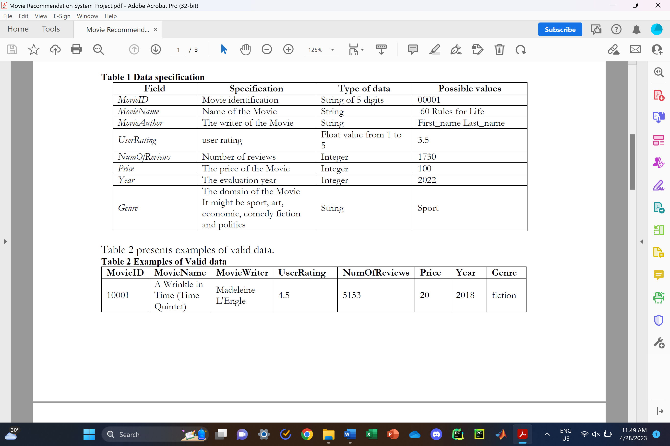

Figure 1

***Design and Implementation (Plan):***

We decided to divide the tasks equally.

Shahad: 1. Add new movie information

2. Display information for all movies

3. Save specific data in new files and exit the program

Leen: 1. Update Movie Information

2. Display specific Information

3. Review the code, comments, variable names, and design the output

4. Collect data and add them to movie.txt

After writing the code, we reviewed the requirements and made sure we met all of them. After that, we worked on the report. While planning what the Python program will be, we decided to create Python functions since the project requirements are limited and short and do not require complex concepts. Also, we create the main function that displays the menu and asks the user what they want to do. (Figure 2) (Figure 3).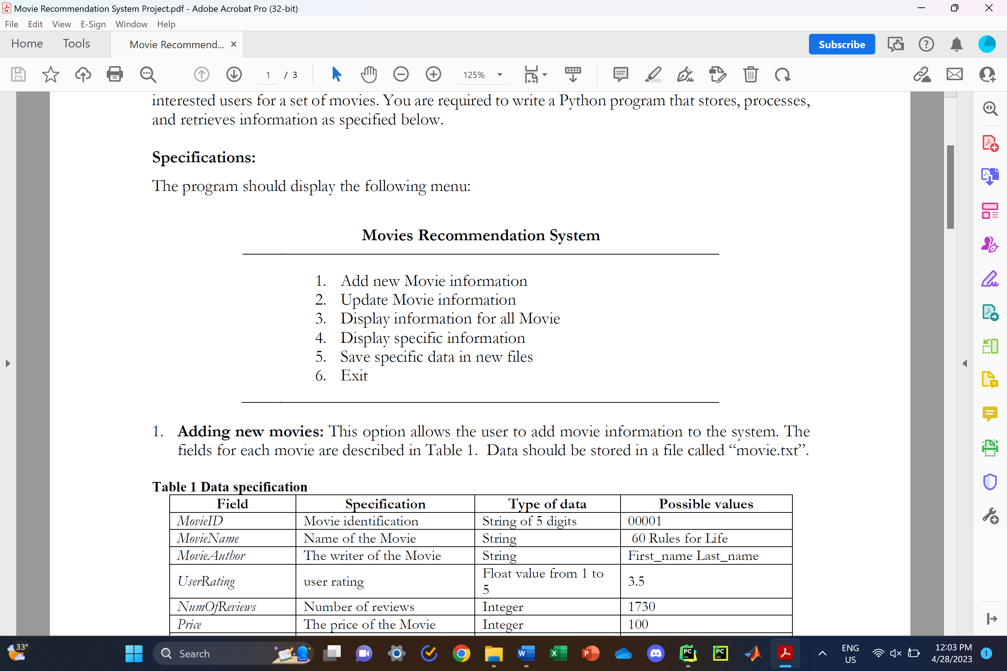

Figure 2

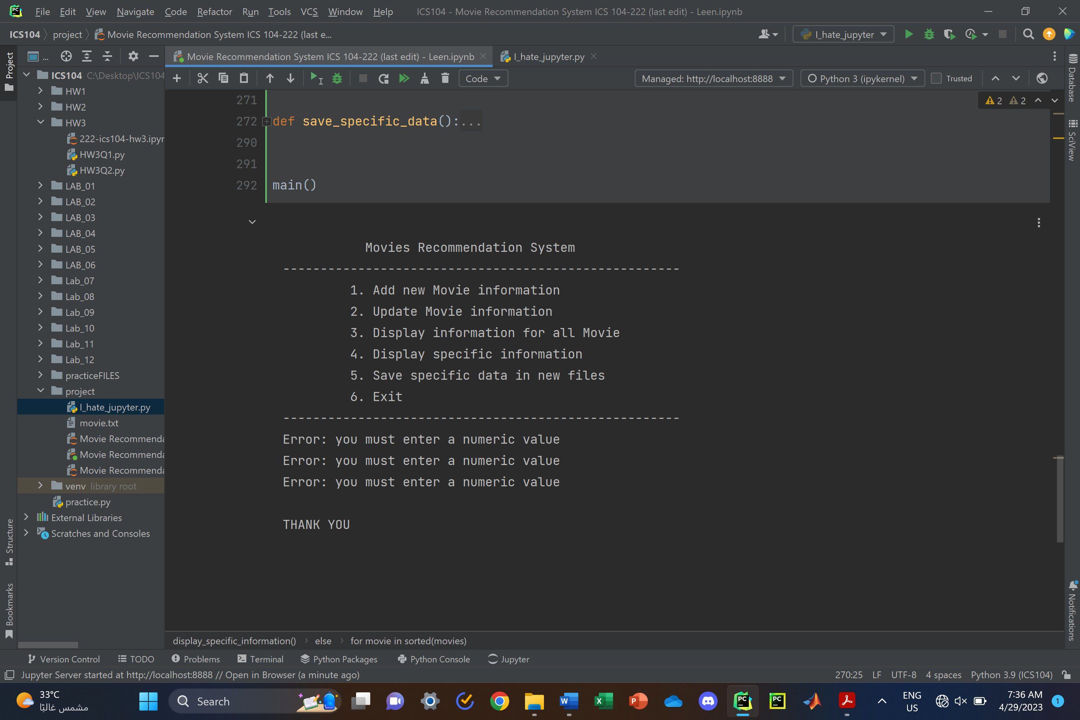

Figure 3: Output

Here is the text context (82 movie to be precise)

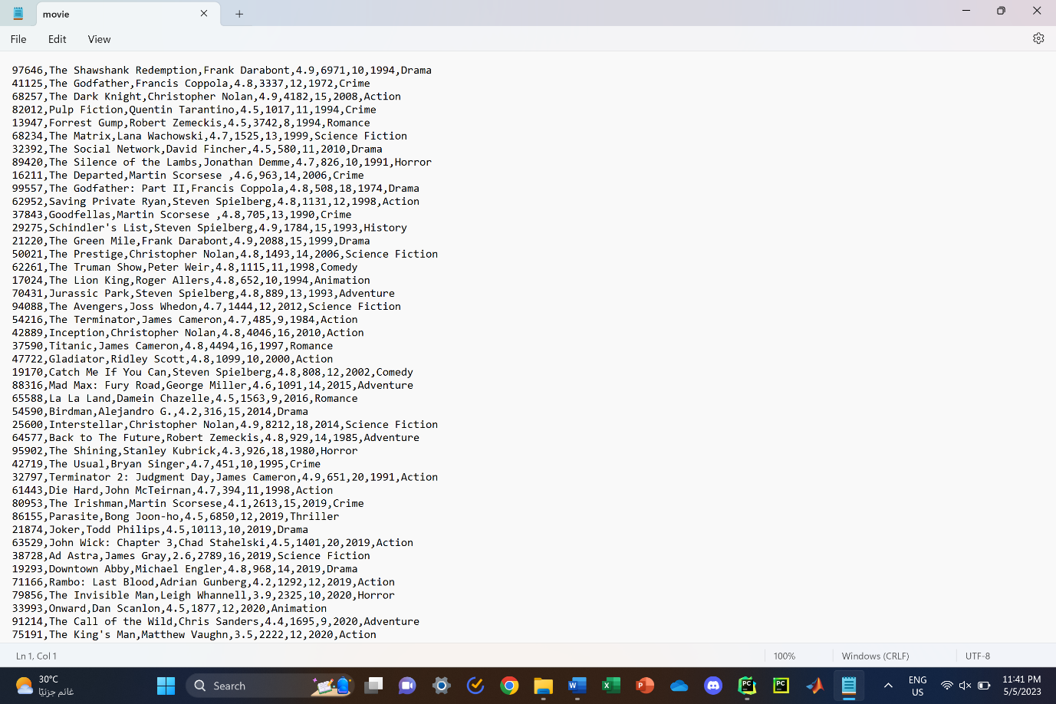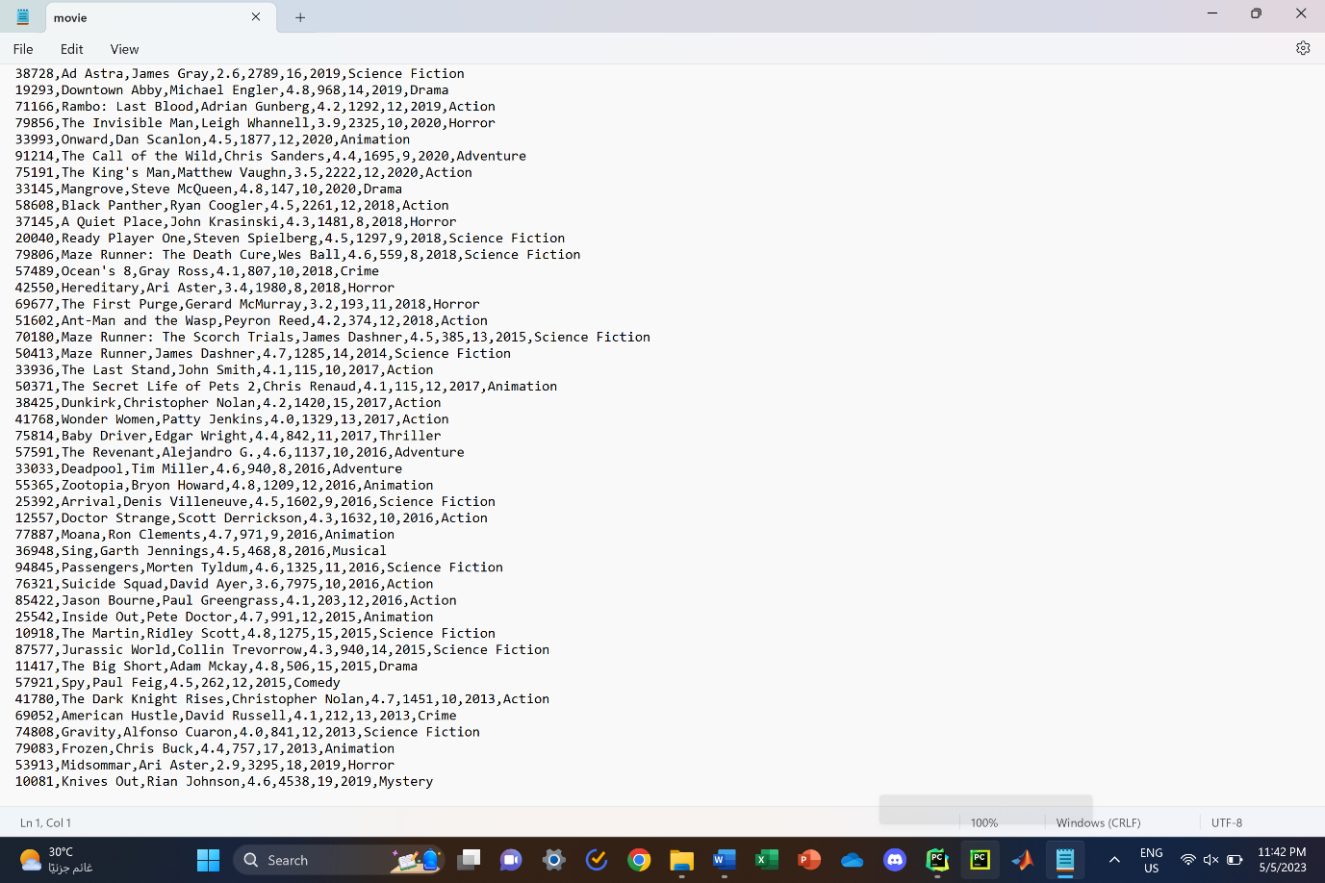

Figure 4: movie.txt

The program has 7 functions (one for every choice displayed in the menu, plus the main function and a function called "Movie Information" that contains all movie data in a 2D array). After the user makes their choice and finishes the process, the program displays the menu again, which allows the user to perform additional modifications until they choose 6 (Exit the program). In addition, this code is linked to a text file called ("Movie.txt"). The purpose of this text is to save all the new information/modifications made by the user (the text has already been filled with 50 movie recommendations).

***Programming Techniques used:***

Here are the functions that were implemented in the code

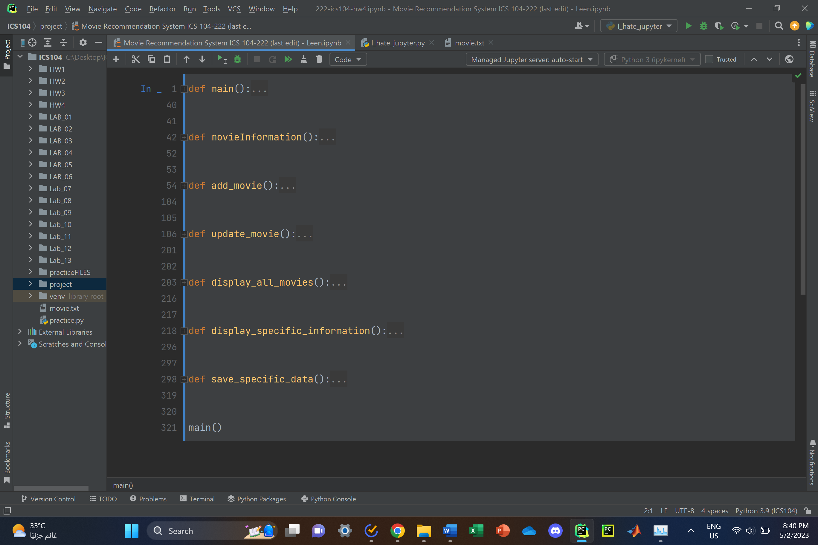

Figure 5: Function Headers

The code mainly consists of for/while loops to read/append/write the text or save it in a 2D array. We also use try and except in every function to avoid getting a runtime error while executing. Additionally, we use clear variable names, such as choice, rating, review, etc. Moreover, we use suitable comments in every function and loop to explain the purpose of using them. The most common loop used is in user validation. We create a try-except concept inside a while loop to validate the user input without getting an IOError.

Leen:

**Function: movieInformation()**

I faced some difficulties regarding updating the movie information and adding them to the text. Since the Python program cannot delete some information or replace it in the text, I decided to read the text and copy all the data as a 2D array (data) in this function. The "data" variable is a 2D array; each element in the data variable has an array of all the 8 pieces of information about each movie as stated above in the requirement section. I used the strip method (to delete spaces and convert to a single character) and the split method (to split information using a comma ‘,’) to convert the context in the text to a 2D array.

**Function (Choice 2): update_movie()**

First, I saved a copy of the movie information using the movieInformation() function in a variable. Then, I retrieved the movie information based on the movie ID and year. After that, I ask the user whether they want to update (User Rating, Number of Reviews, and Price). If yes, the program adds the new information (new) based on the modifications above in the 2D array (a copy of the movie data) and deletes the previous movie information (old). I use the mode ‘w’ when opening the text file and rewrite all the information in the same format. If not, the program returns to the menu.

**Function (Choice 4): display_specific_information()**

For displaying specific information, it was much easier than updating the information. All I need to do is validate the user's choice and display the information. I decided to implement all the sub-options to enable the user to perform more options. However, I ran out of time, so I continued with the initial four sub-options I had already chosen.

1- Print the total price of all movies per year.

2- Print the average price of all movies per year.

3- Print the average price of all (unique) movies per author.

4- View a sorted list of movies (by movie name) for a given year (in alphabetical order).

Just like the previous function, I use the movieInformation function for a copy. I accessed the price, year, movie name, and author name depending on their position in the 2D array. In this function, I planned to use dictionaries. Using dictionaries to print specific movie information helps me align my information with each year or author. For the last choice, I used the sorted function to print my list of movie names in alphabetical order.

After writing the code, the reviewing process was very easy and took less time than expected because me and my partner had already used comments and suitable variable names while coding. I spent some time trying to format function 3. It was challenging but I figured it out. So, I started working on the text file and collecting the data required for more than 50 movies. I asked ChatGPT to generate a data set for more than 50 movies, but OpenAI was not available in Saudi Arabia, so I used a similar generator. It was very hard to manage with all the restrictions on the information and how reliable it is. However, the result was not as I expected because it is not a real generator. As a result, the review process took longer than expected. Additionally, I used random module to generate more that 80 unique ID and add them to the text file.

Shahad:

**Function (Choice 1): add_movie()**

This is a function called "add_movie" that allows a user to input information about a movie and save it to a file called "movie.txt". The function first tries to open the "movie.txt" file in "append" mode using the "with open" statement. This means that if the file doesn't exist, it will be created, and if it does exist, any new information will be added to the end of the file. The user is prompted to enter the movie ID, which must be 5 digits and only contain numbers. If the user enters an invalid ID, they will be prompted to try again until they enter a valid ID. The user is then prompted to enter the movie name, writer, user rating, number of reviews, price, year, and genre. If the user enters an invalid value for any of these inputs, they will be prompted to try again until they enter a valid value. Once all of the movie information has been entered, it is written to the "movie.txt" file in a comma-separated format.

If the user enters an invalid value at any point during the input process, a "ValueError" exception will be raised. The function will catch this exception and print an error message, prompting the user to try again. After the user has been given the option to try again, the "finally" block will close the file.

OPTIONAL: If the user enters an invalid value, they will be prompted to try again. If they choose to try again, the function will call itself recursively to start the input process over again.

**Function (Choice 3): display_all_movies()**

This function reads the contents of a file called "movie.txt" and prints each row of the file as a list of values. The function first tries to open the "movie.txt" file in "read" mode using the "with open" statement. This means that the file will be opened for reading, and if it doesn't exist, an "IOError" exception will be raised. The "readlines" method is called on the file object to read all of the lines in the file and return them as a list of strings. The function then loops through each line in the list and prints it as a list of values. This is done by calling the "strip" method on the string to remove any leading or trailing whitespace characters, and then calling the "split" method with a comma as the argument to split the string into a list of values based on the comma-separated format of the file. After all of the rows have been printed, the "finally" block will close the file.

If the "with open" statement raises an "IOError" exception, the function will catch it and print an error message. This could happen if the "movie.txt" file doesn't exist or if there is a problem with the file (e.g., it is locked by another program). In this case, the function will print an error message and the exception message using the "str" function to convert the exception object to a string.

**Function (Choice 5): save_specific_data()**

This function allows a user to save specific movie data to a new file based on a movie ID and year. The function prompts the user to enter the movie ID, year, and filename for the new file. The function then opens the "movie.txt" file in "read" mode using the "with open" statement, reads all of the lines in the file using the "readlines" method, and stores them as a list of strings in the "rows" variable. The function creates an empty list called "data" to store the rows that match the movie ID and year. The function then loops through each row in the "rows" list and checks if the first field (movie ID) and the seventh field (year) match the user input. If they do, the entire row is appended to the "data" list.

If there are any rows in the "data" list, the function opens a new file with the filename entered by the user in "write" mode using the "with open" statement. It then loops through each row in the "data" list and writes it to the new file as a comma-separated string using the "join" method to join the values in the row and the "\n" character to add a newline at the end. Finally, it prints a success message indicating that the data was saved to the new file.

If there are no rows in the "data" list, the function prints a message indicating that no movie was found with the given ID and year. Overall, this function provides a way for a user to extract specific movie data from the "movie.txt" file and save it to a new file for further analysis or processing.

***Instructions / Testing and Maintenance:***

To launch the program, the instructor will need to download the Jupyter file and the text file in the same folder. After that, the instructor will open the Jupyter file and run the first code cell.

To test the code, we use the example of movie information mentioned in the project file. We also tried to give the program several invalid inputs to make sure the code did not crash during execution.

If we have more time, we will create more options for the last two choices in the menu. We will implement all the options included in the project file so the user has a variety of choices. Additionally, we will create function for each data validation instead of repeating the validation algorithm in each choice function. The figures below show some of the output of the program.

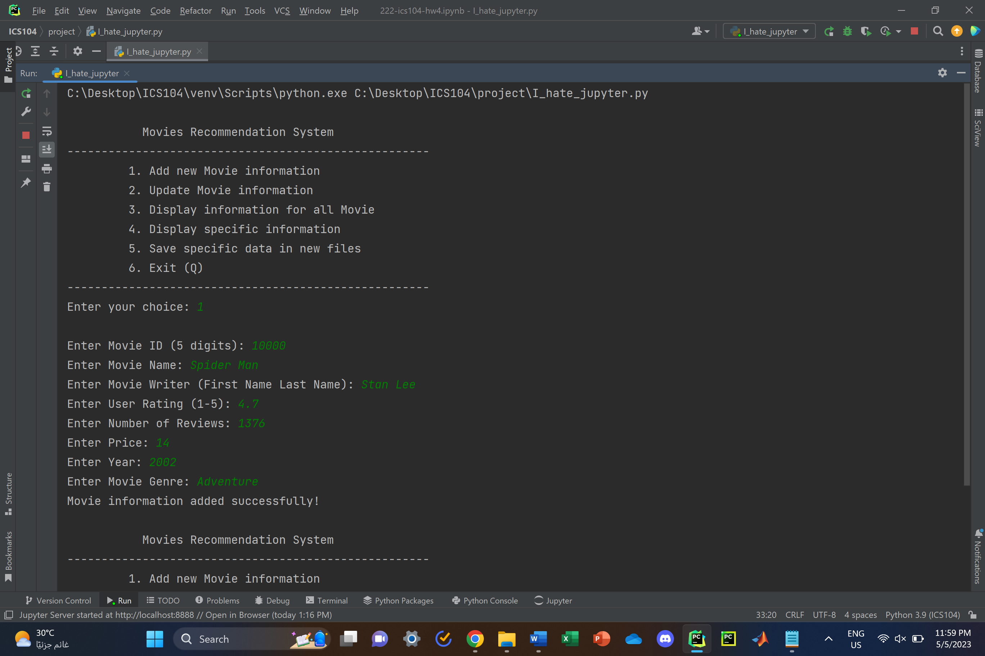

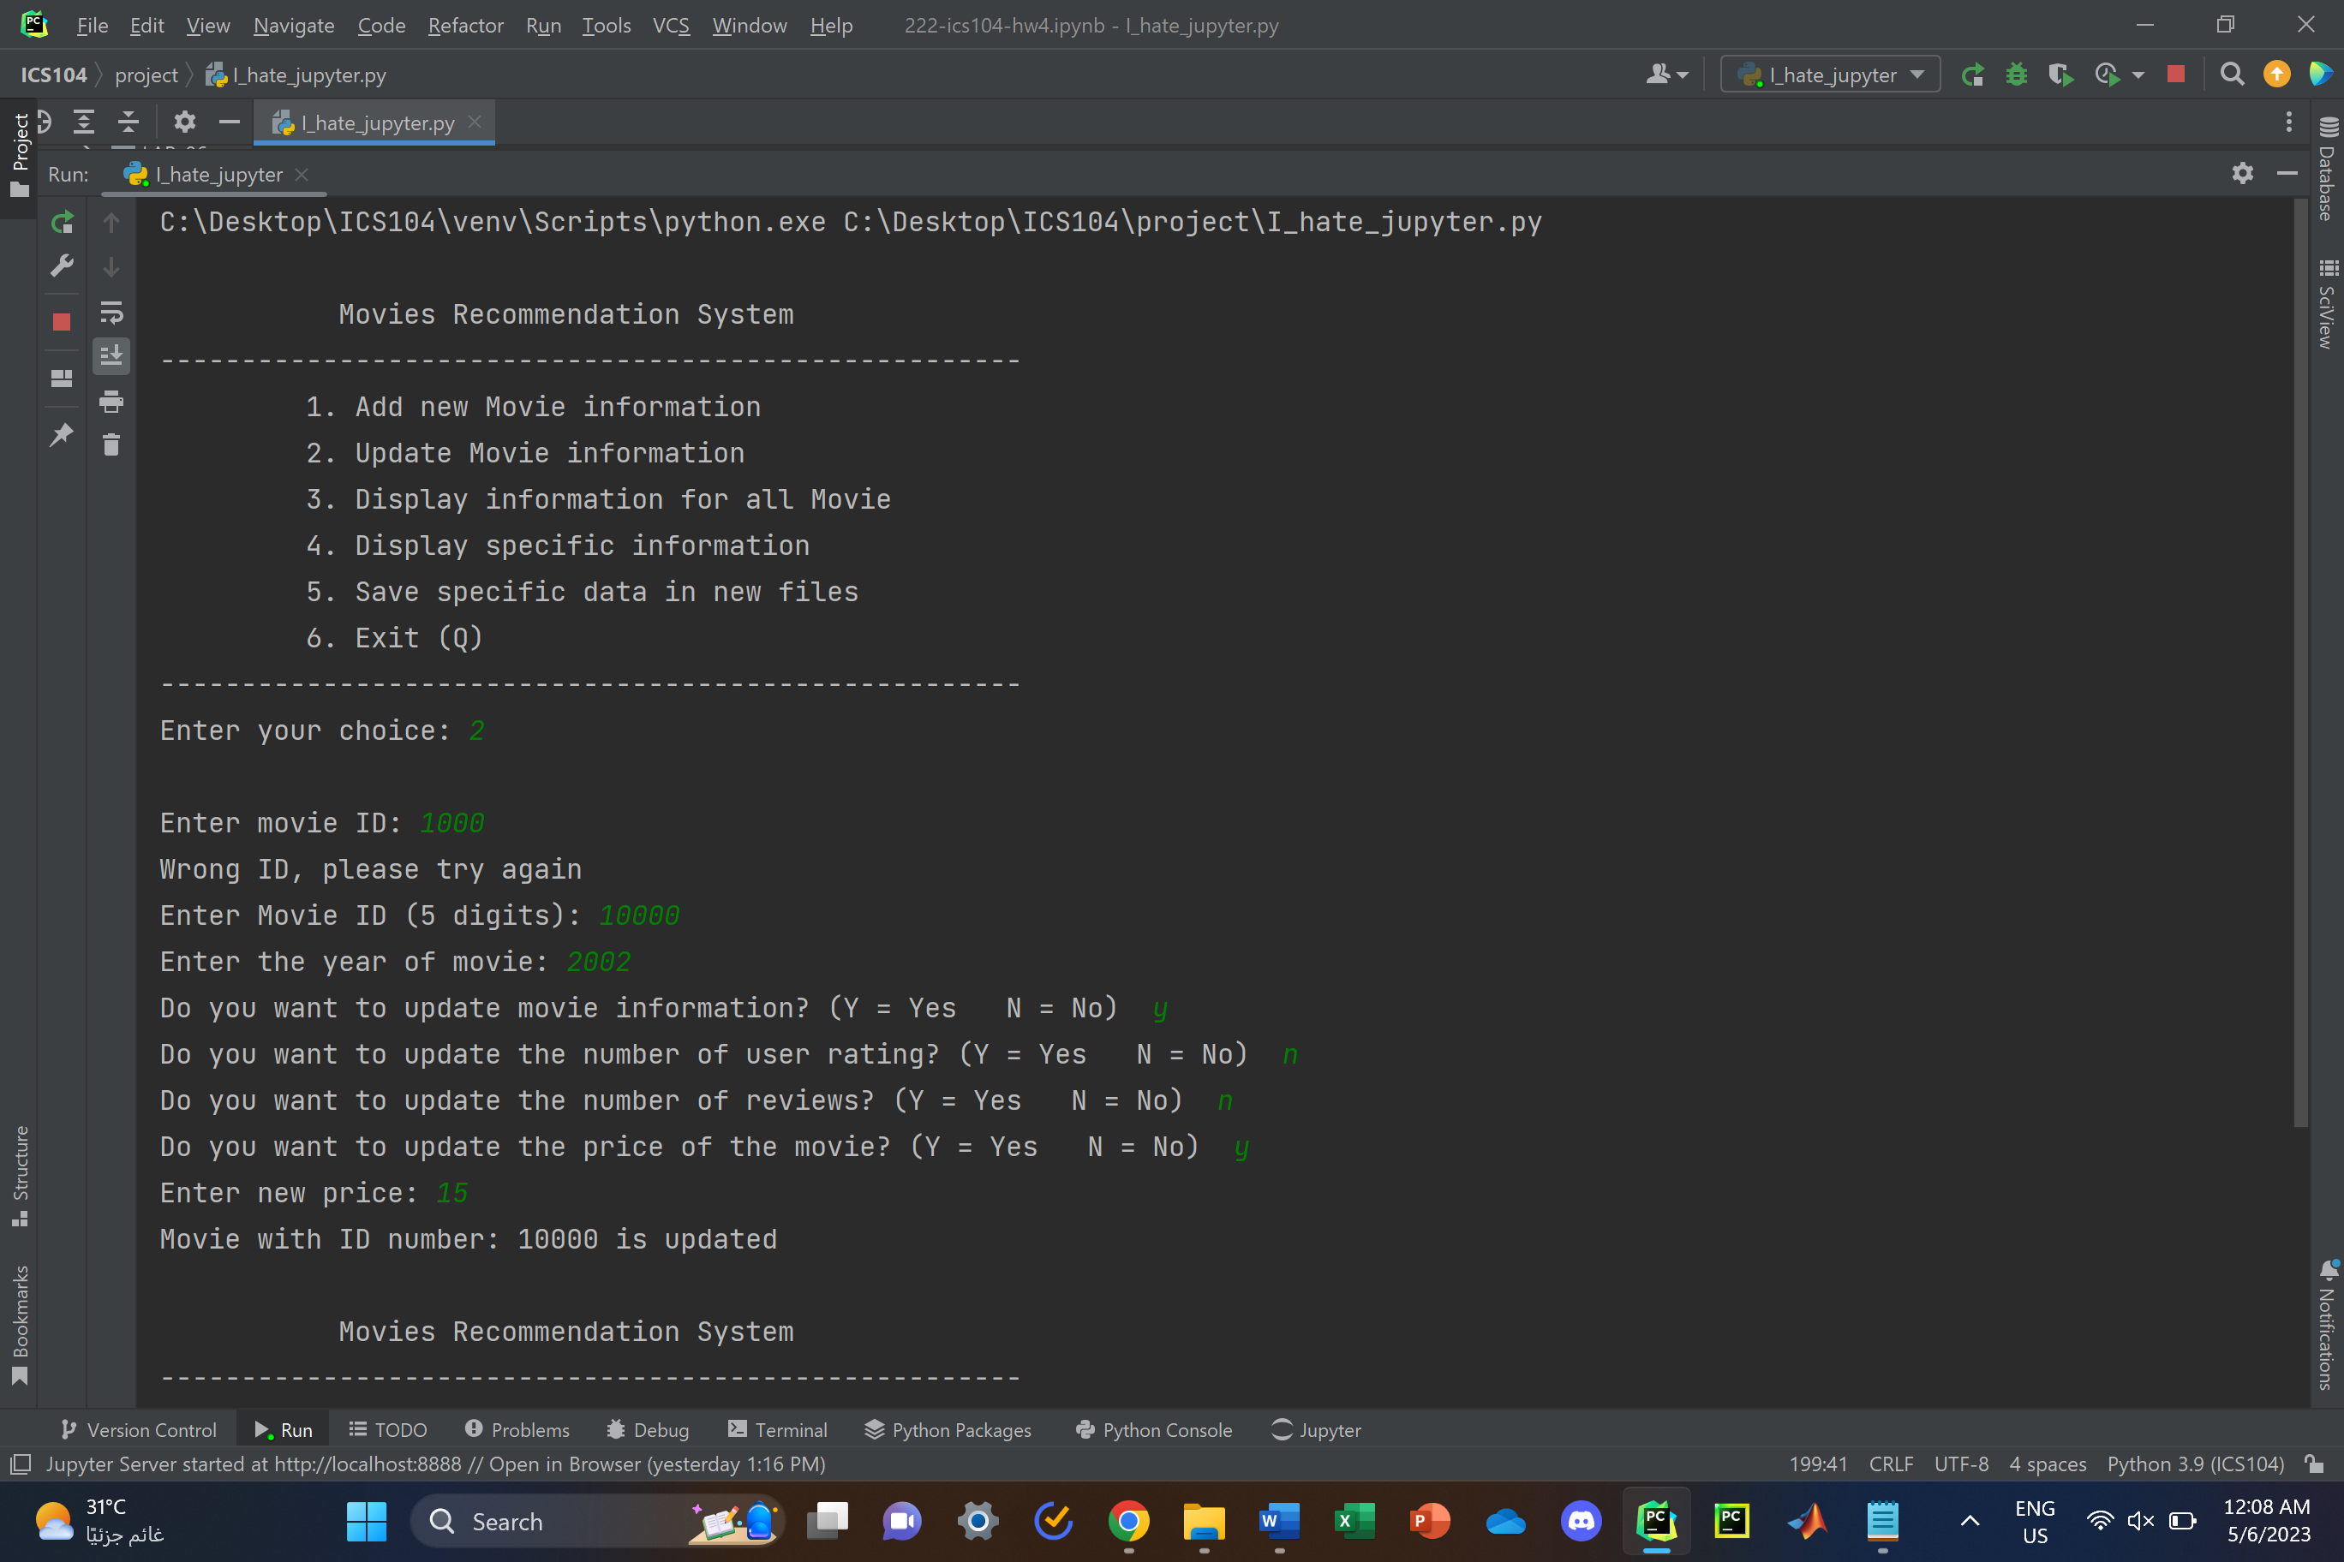

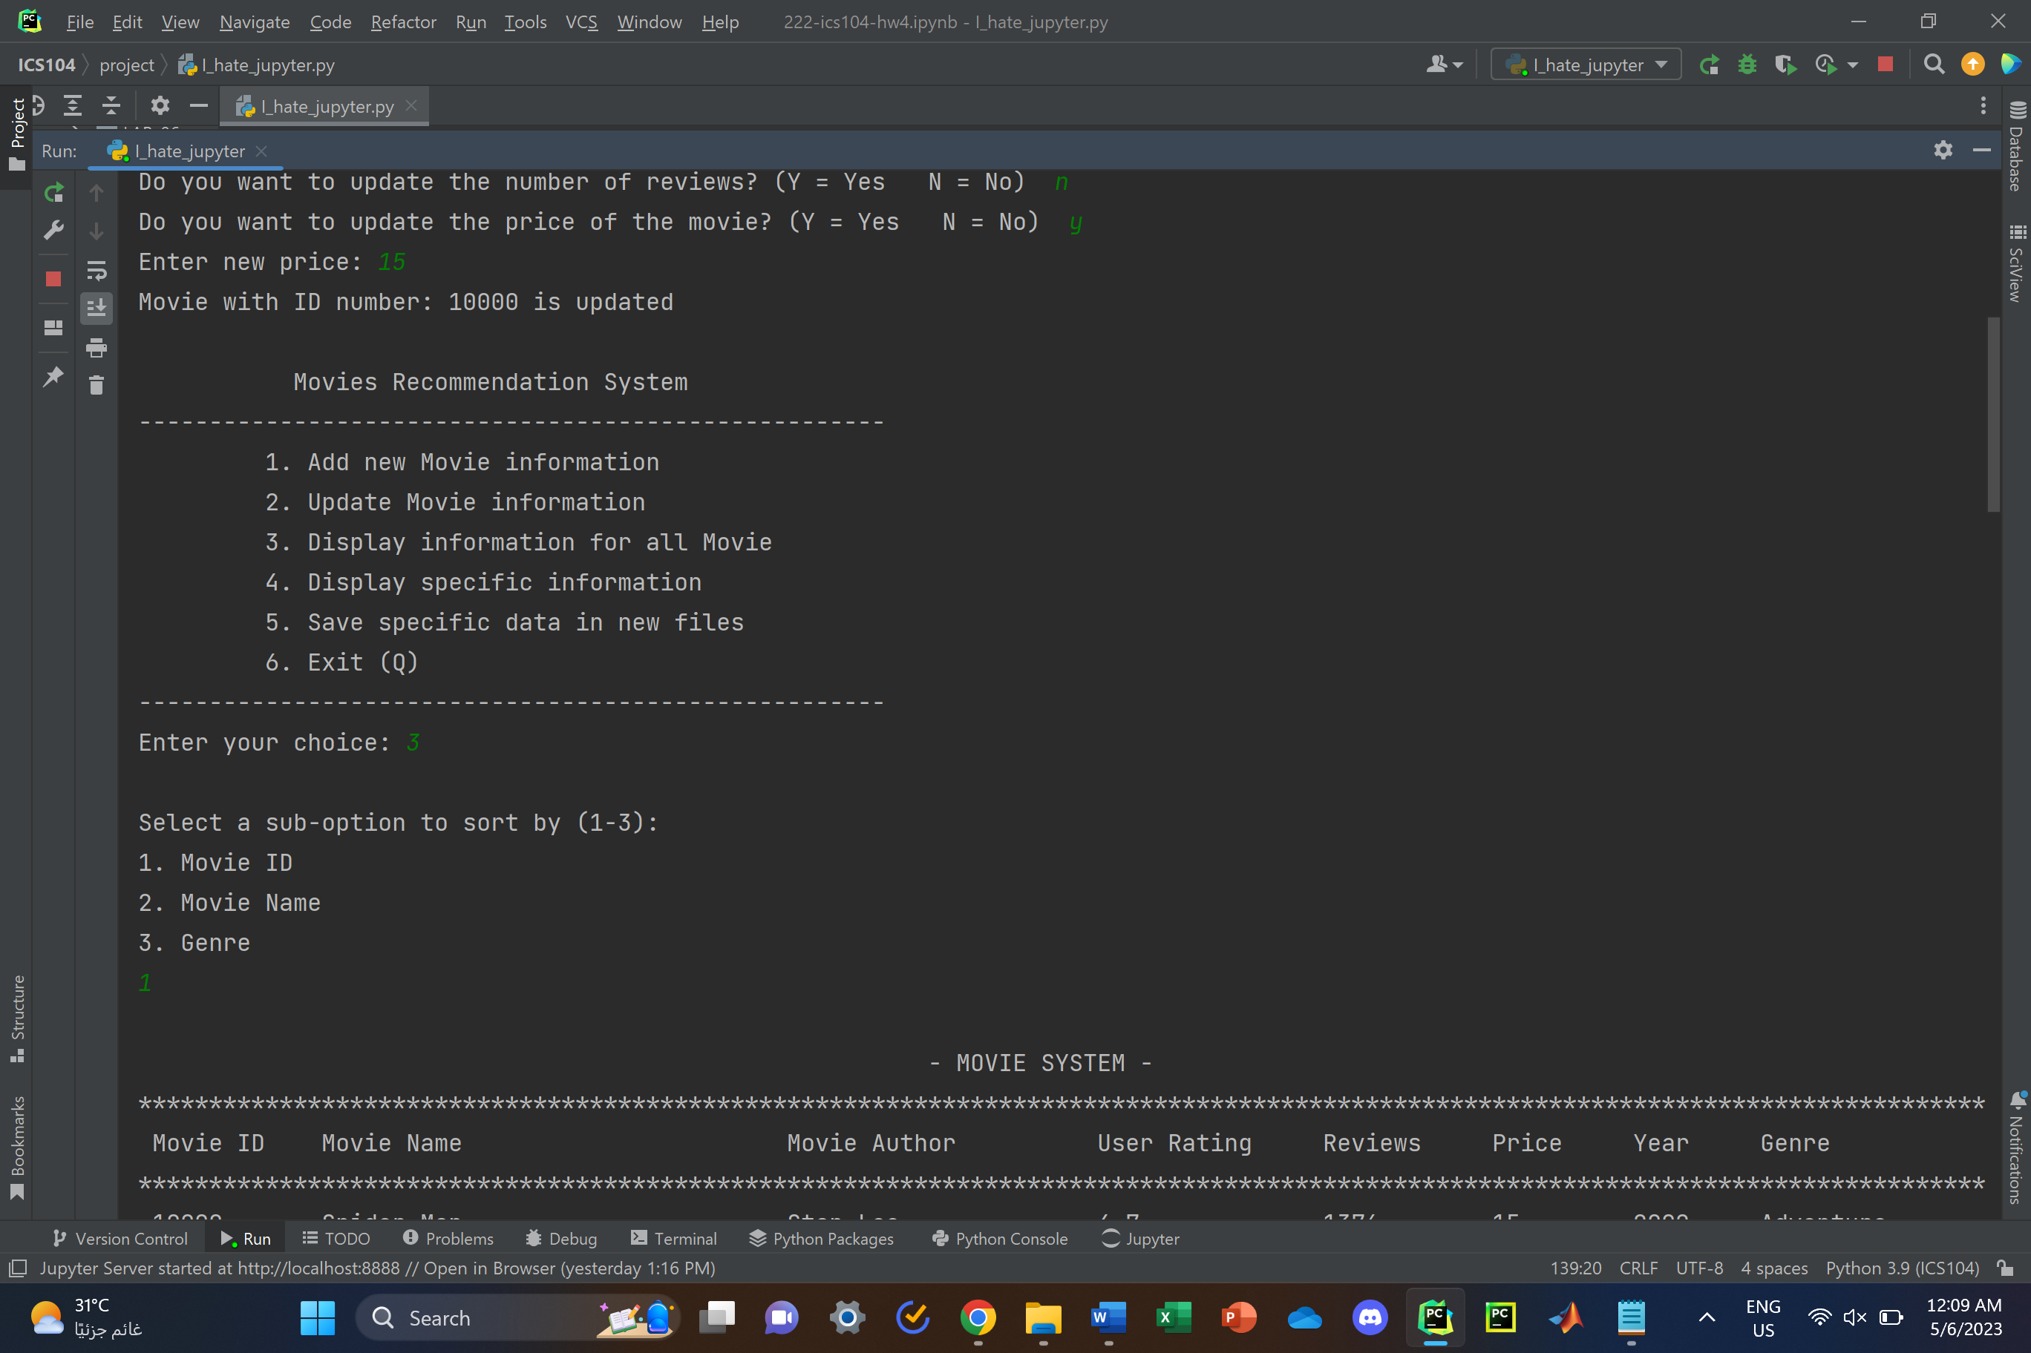

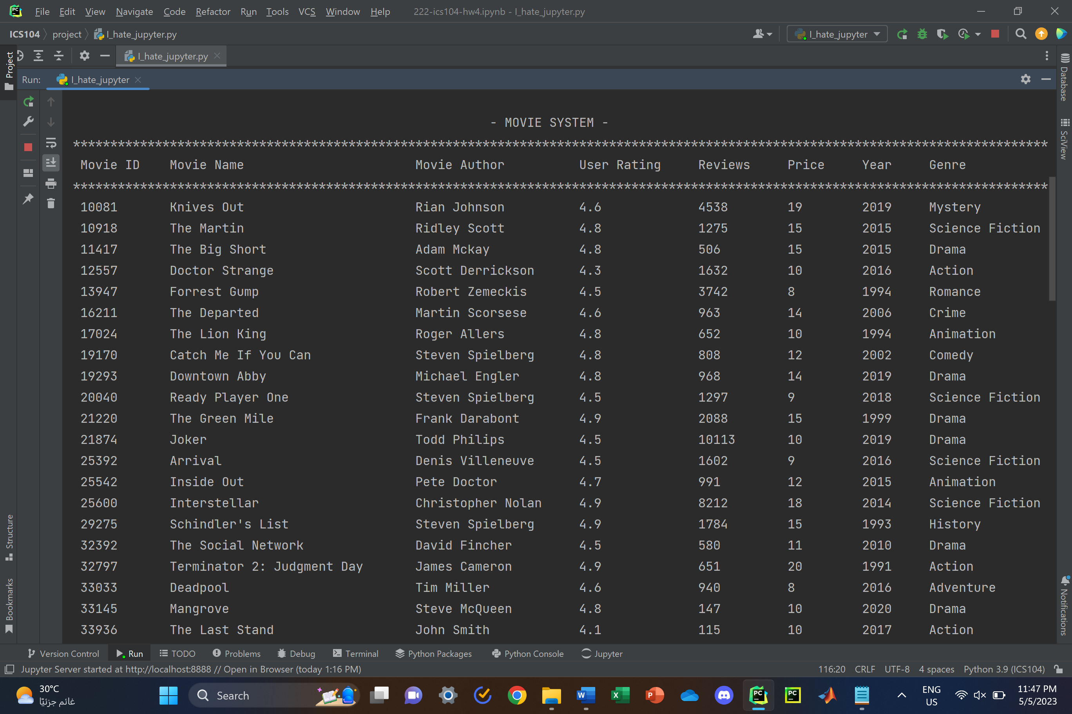

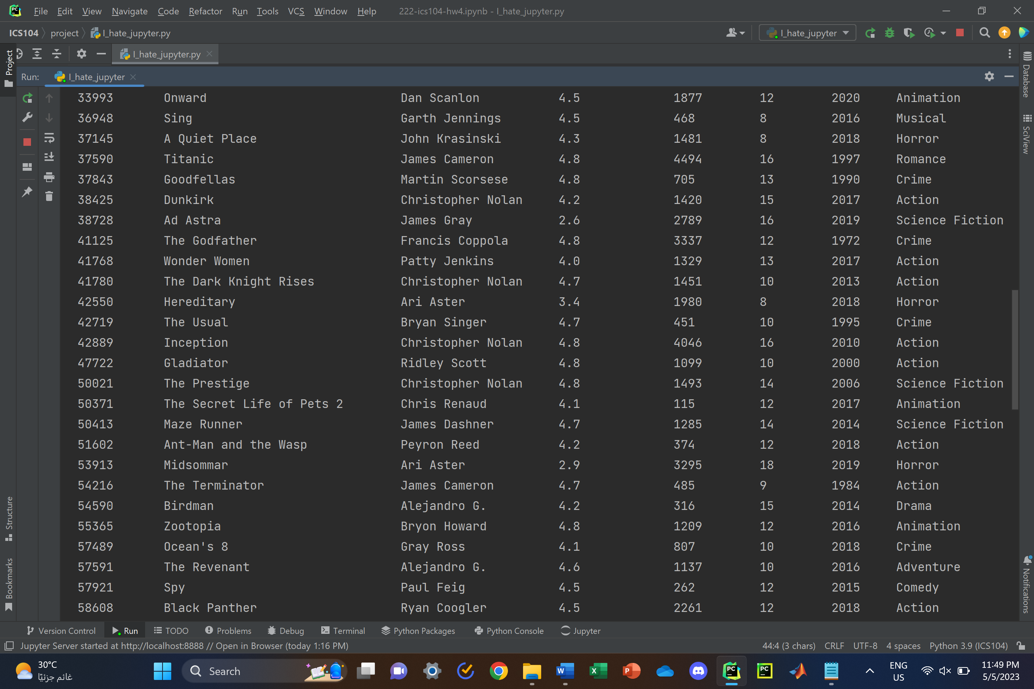

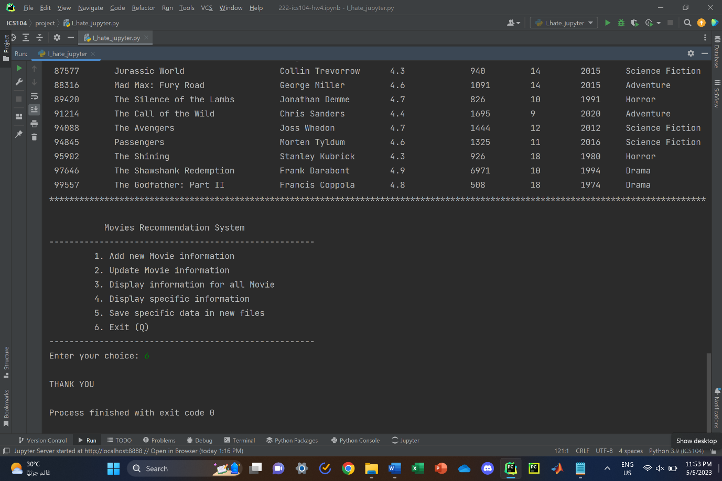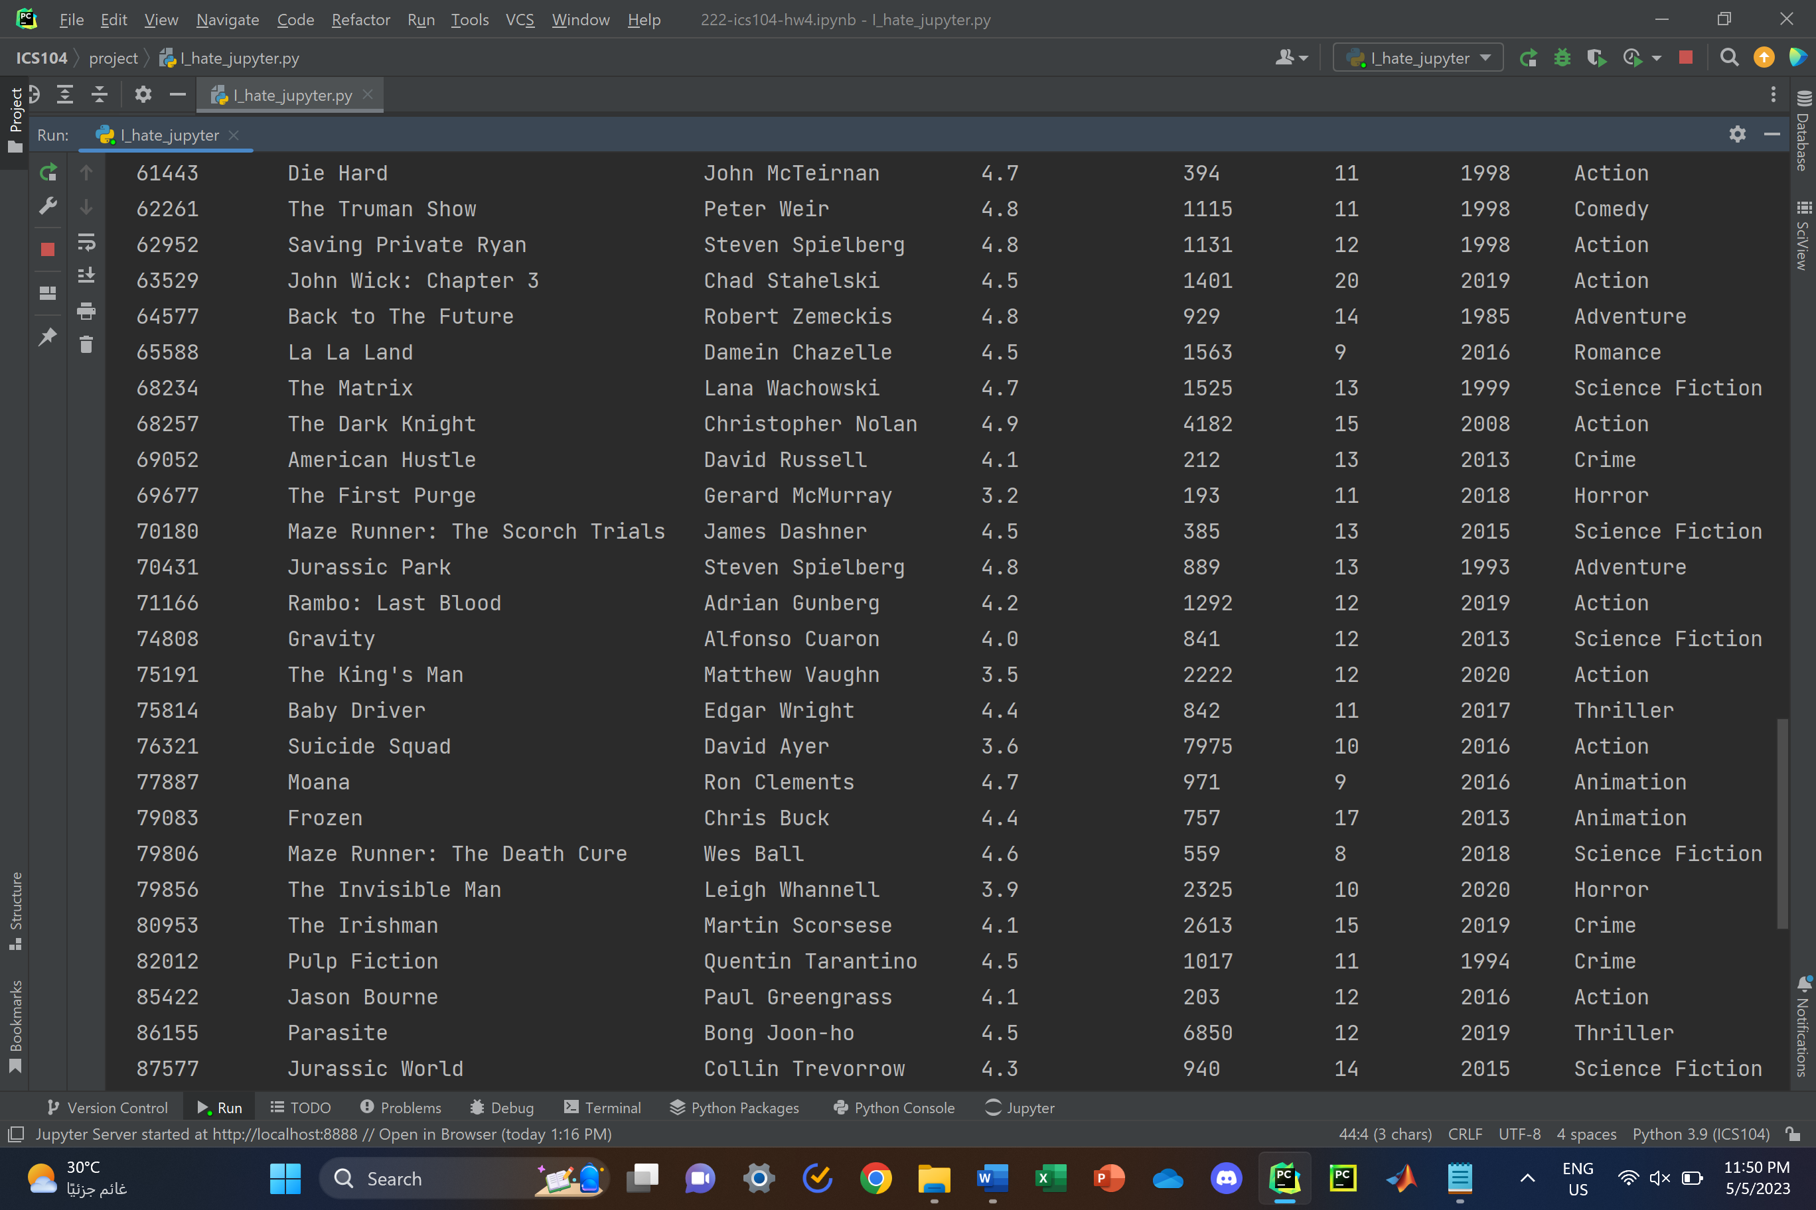

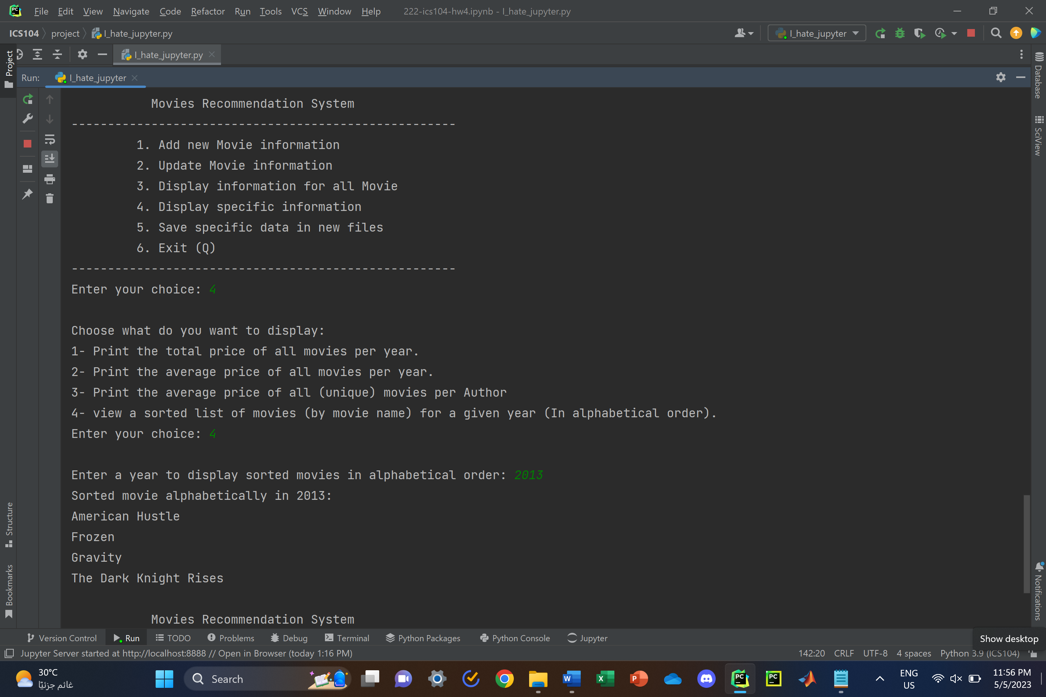

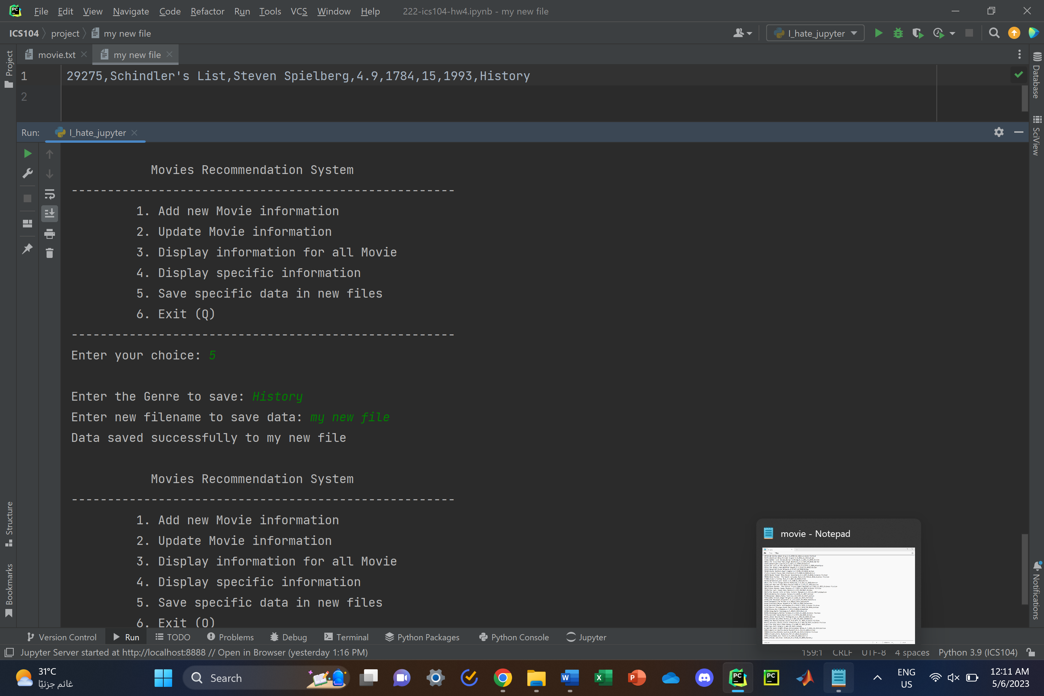

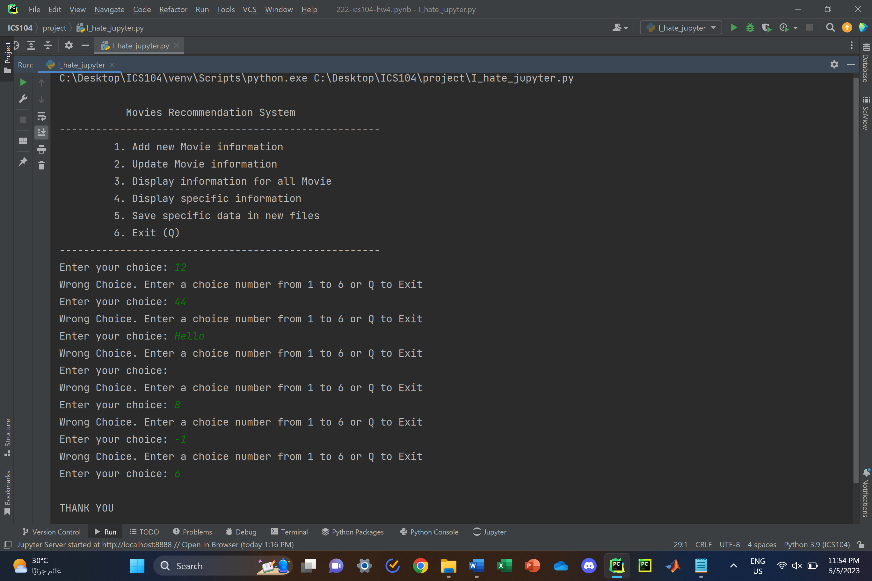

Figure 7: Output

***References (If there is any):***

ICS104 Lectures in blackboard

StackOverFlow (To explore programming algorithms)

ChatGPT (To generate movie information)

IMBD (Movie Information Main Source)